Calc free solutions

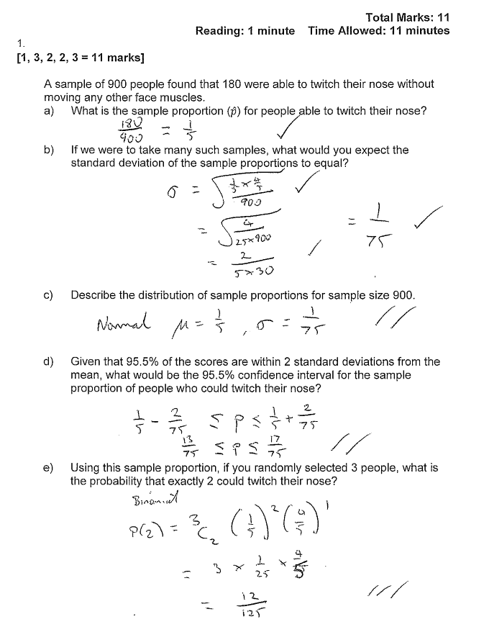

**Question 2(a)**

|  |  |
| --- | --- |
| Solution  A census involves **every member** of the **population** being tested/questioned/investigated |  |
| Marking key/mathematical behaviours | Marks |
| * indicates the need to include every member of the population | 1 |

**Question 2(b)**

|  |  |
| --- | --- |
| Solution  There would be no stoves left to sell as all of them would have broken down. | |
| Marking key/mathematical behaviours | Marks |
| * indicates that there would be no items left for sale (no marks for cheaper or quicker) | 1 |

**Question 2(c)**

|  |  |
| --- | --- |
| Solution  Use the unique serial numbers to select a random sample or similar | |
| Marking key/mathematical behaviours | Marks |
| * indicates use of a suitable random selection method (based on serial numbers or other method) | 1 |

**Question 2(d)**

|  |  |
| --- | --- |
| Solution  Using the list of the serial numbers, select every 400th stove | |
| Marking key/mathematical behaviours | Marks |
| * indicates use of a suitable selection method | 1 |

**Question 4(a)(i)**

|  |  |
| --- | --- |
| Solution  Approximately 200 samples are involved | |
| Marking key/mathematical behaviours | Marks |
| * States the number of samples (allow 190 to 210) | 1 |

**Question 4(a)(ii)**

|  |  |
| --- | --- |
| Solution  Find the mean of the sample proportions, (from the graph)  0.4  May use sample proportion as an estimate of the population proportion | |
| Marking key/mathematical behaviours | Marks |
| * identifies sample proportion as 0.4 (by reference to the graph or calculation) * uses the sample proportion as an estimate for the population proportion | 1  1 |

**Question 4(b)**

|  |  |
| --- | --- |
| Solution   * Survey is restricted to listeners of one particular station and therefore not representative of the population * Survey is using a self-selection model and this indicates bias * Timing may exclude some groups of people * Access to a telephone is presumed * People could respond more than once * Nature of the question means football fans may be more likely to respond |  |
| Marking key/mathematical behaviours | Marks |
| * Lists one possibility * Lists a second possibility | 1  1 |

Calc Solutions

Question 12 (8 marks)

From a random survey of 524 users of a free music streaming service, it was found that 386 would stop using it if they had to pay.

(a) Based on this survey, calculate the percentage of users who would stop using the service. (1 mark)

|  |
| --- |
| **Solution** |
| $$\frac{386}{524}×100=73.7\%$$ |
| **Specific behaviours** |
| ✓ calculates percentage |

(b) Calculate the approximate margin of error for a 90% confidence interval estimate of the proportion of users who would stop using the service. (3 marks)

|  |
| --- |
| **Solution** |
| $$z_{0.9}=1.645 \\ SE=\sqrt{\frac{0.737(1-0.737)}{524}}=0.01924 \\ E=1.645×0.01924=0.0316$$ |
| **Specific behaviours** |
| ✓ uses correct $z$-score  ✓ calculates standard error  ✓ calculates margin of error |

(c) Determine a 90% confidence interval for the proportion of users who would stop using the service. (2 marks)

|  |
| --- |
| **Solution** |
| $$0.737±0.032=(0.705, 0.768)$$ |
| **Specific behaviours** |
| ✓ writes interval  ✓ rounds to 2, 3 or 4 decimal places |

(d) If 50 identical surveys were carried out and a 90% confidence interval for the proportion was calculated from each survey, determine the probability that exactly 48 of the intervals will contain the true value of the proportion. (2 marks)

|  |
| --- |
| **Solution** |
| $$Y\sim B\left(50, 0.9\right)$$ $$P\left(Y=48\right)=0.0779$$ |
| **Specific behaviours** |
| ✓ states parameters of binomial distribution  ✓ calculates probability |

Question 14 (8 marks)

A researcher wants to estimate the proportion of Western Australian school-aged students who participate in organised sport during school holidays. The researcher plans to collect sample data by visiting schools and asking students.

(a) Discuss two different sources of bias that may occur when the researcher collects their sample data and suggest a procedure to avoid bias. (4 marks)

|  |
| --- |
| **Solution** |
| Undercoverage (*including volunteer or convenience sampling*) - the researcher should ensure that all students have an equal chance of being selected, rather than favouring gender, age, state, etc  Nonresponse - some students may choose not to answer the question  Etc, etc  To avoid bias use  Simple random sampling - number all students and select numbers at random  Systematic sampling - number all students and select every th student  Etc, etc |
| **Specific behaviours** |
| ✓ discusses one source of bias  ✓ discusses second source of bias  ✓ suggests a suitable type of sampling  ✓ explains sampling procedure |

(b) Determine, to the nearest 10, the sample size the researcher should use to ensure that the margin of error of a 90% confidence interval is no more than 6%. (3 marks)

|  |
| --- |
| **Solution** |
| $$n=\frac{{1.645}^{2}\left(0.5\right)\left(1-0.5\right)}{{0.06}^{2}} \\ n=188$$ $$\text{Sample size of }190 \text{students}$$ |
| **Specific behaviours** |
| ✓ assumes  ✓ shows sample size equation  ✓ calculates $n$ |

(c) Comment on how your answer to (b) would change if the researcher had a reliable estimate that the population proportion was close to 20%. (1 mark)

|  |
| --- |
| **Solution** |
| Size of sample would decrease (*to close to 120*) |
| **Specific behaviours** |
| ✓ states decrease |

Question 20 (6 marks)

A random sample of 510 rabbits from a nature reserve are captured, tagged and then set free. After a suitable interval, during which time it is assumed that the rabbit population does not change, another random sample of 300 rabbits is caught and 18 of these are observed to be tagged.

(a) Show that a point estimate for the size of the rabbit population is 8 500. (1 mark)

|  |
| --- |
| **Solution** |
| $$\frac{510}{P}=\frac{18}{300}⇒P=8500$$ |
| **Specific behaviours** |
| ✓ shows use of direct proportion |

(b) Construct a 90% confidence interval for the proportion of rabbits in the population that are tagged. (2 marks)

|  |
| --- |
| **Solution** |
| $$\hat{p}=\frac{18}{300}=0.06, E=0.02255, z_{0.9}=1.645$$ $$(0.0374, 0.0826)$$ |
| **Specific behaviours** |
| ✓ calculates margin of error  ✓ states confidence interval |

(c) Deduce an approximate 90% confidence interval for the number of rabbits in the reserve.

(3 marks)

|  |
| --- |
| **Solution** |
| $$P_{L}=\frac{510}{0.0826}=6174$$ $$P_{U}=\frac{510}{0.0374}=13636$$ $$(6200, 13600)$$ |
| **Specific behaviours** |
| ✓ calculates lower value  ✓ calculates upper value  ✓ rounds sensibly (eg 00's) |

20. (a) A sample that reflects the whole population. ✓

(b) 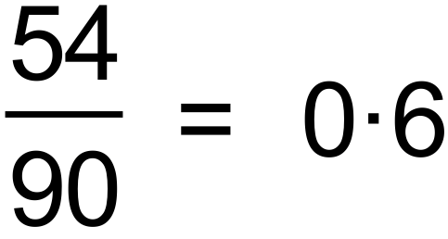 ✓

(c) 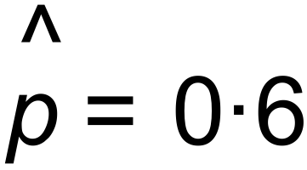

∴ 90% confidence interval

= 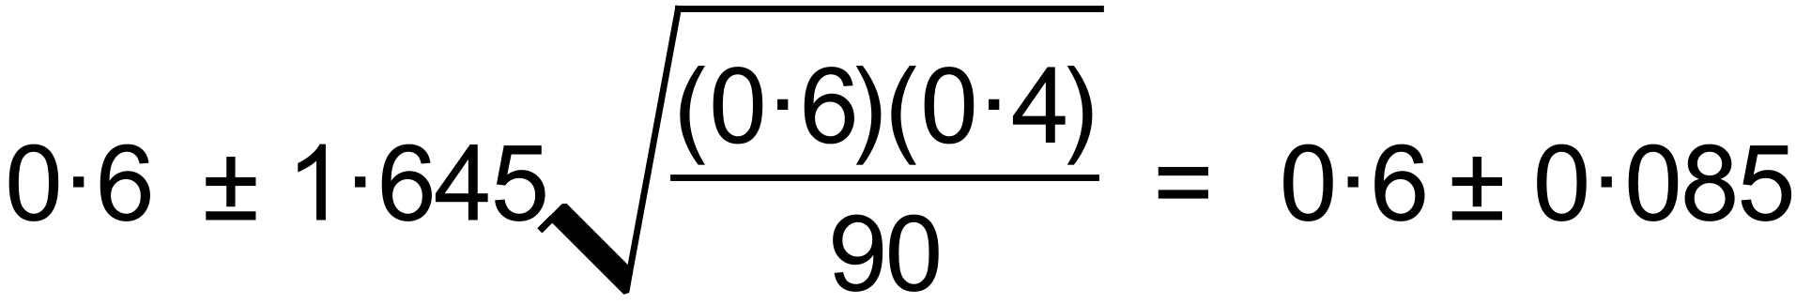 ✓✓

= 0.515  0.685 ✓✓

(d) (i) 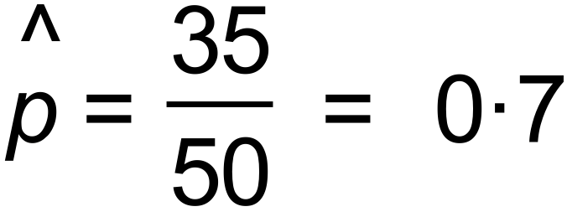

Since not in the 90% confidence interval probably not

in the cohort of Year 4 students. Maybe a higher grade. ✓

(ii) 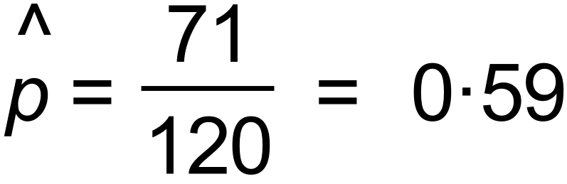

90% confidence interval

= 0.518  0.665 ✓

∴ Can reasonably expect that the sample came from the

Year 4 cohort, as this interval is within the bounds. ✓ [9]

**Question 11(a)**

|  |  |
| --- | --- |
| Solution  Population would be all the people eligible to vote in the election  Sample is the 100 voters asked | |
| Marking key/mathematical behaviours | Marks |
| * Identifies population correctly * Identifies sample correctly | 1  1 |

**Question 11(b)**

|  |  |
| --- | --- |
| Solution  Use a method to randomly choose 100 people from the electoral role | |
| Marking key/mathematical behaviours | Marks |
| * states a suitable method | 1 |

**Question 11(c)**

|  |  |
| --- | --- |
| Solution  For 100 estimate of proportion is 0.35  For 200 $E\left(\hat{p}\right)=0.35$ Std Dev $(\hat{p})$ = $\sqrt{\frac{0.35(1-0.35)}{200}}$ = 0.03373 $\hat{p } \sim N(0.35. {0.03373}^{2})$ $P\left(0.3< \hat{p}<0.4\right)=$  0.8618 | |
| Marking key/mathematical behaviours | Marks |
| * evaluates the standard deviation accurately * states distribution of $\hat{p}$ correctly * Evaluates correct probability | 1  1  1 |